This is Graham’s take on WD 3.2. Please use it as guidance only.

## **3.2 Identify the components required by a web-site design.**

**Front end elements: (customer or users)**

Screenshot and 1 sentence on each

* **Navigation structure (menu) -** Here, you can see I have designed a navigation bar to allow users to navigate between the pages of my website

The default text colour is Grey, the hover over is an orange and the visited or current page shows in pink.

* **Page layout -** Prior to implementing the web site we should show the customer some mock up layouts colour schemes etc to allow them to sign off on our ideas Below you can see that you can do the initial mock up designs and layouts for a website in a variety of ways using mock up software, templates or even hand drawn designs It is also very important to consider your designs responsiveness to a variety of different devices such as mobile phones, ipads and PC’s which are all different sizes and shapes.

Can be pencil drawings or mock-ups <https://moqups.com/>

Here you can see I have produced a mock up for my home page colour scheme mobile design etc

* **Logo -** Having a good logo is an important part of the businesses corporate identity. Here you can see I have created a logo in the [www.Vectr.com](http://www.Vectr.com) vector design programme

Here you can see that I have produced a logo with Photopea

* **Content (text/videos/images) –** Content for a web page would include things like, photographs, text, background images, videos, buttons, menus etc. Here you can see I have started adding content to my web site.

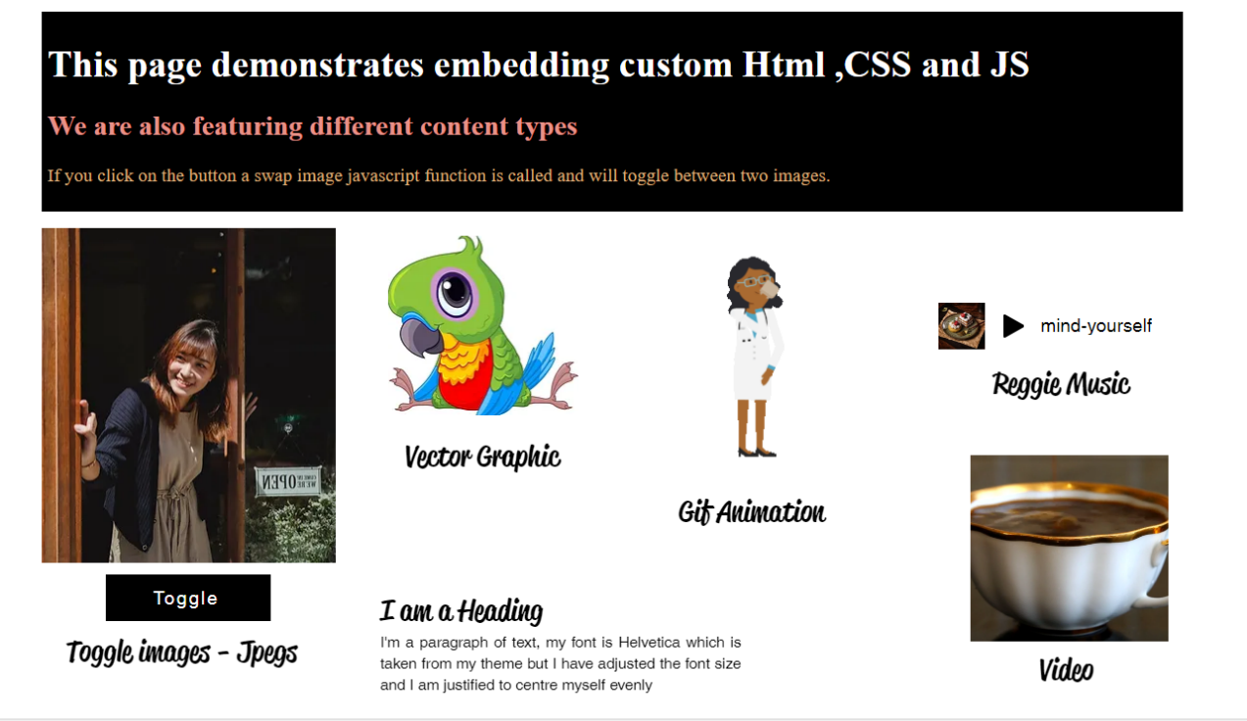

Here you can see I have added a variety of content

* **Design –** One of the most important aspects of designing a web site is to establish a theme. This would include making decisions on the colours to be used and the font styles and sizes. This will give the web site a continuity to the design throughout.

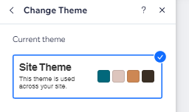 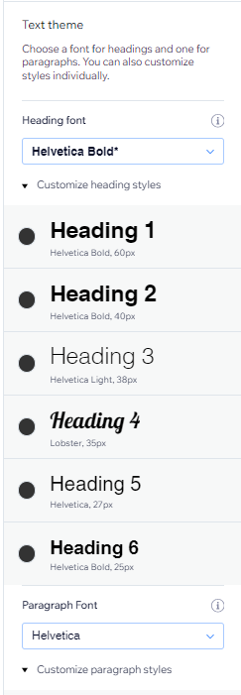

Here you can see the themes for my web site

**(45 Minutes)**

**Backend elements (Web Developers or Administrator)**

* **Blog posts –** Here you can see I have added an interactive blog to my website with three posts which the users can read and add their comments.

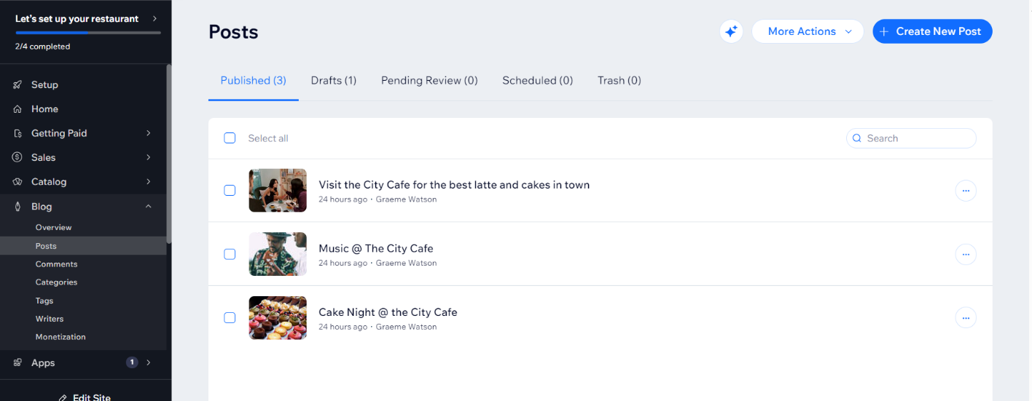

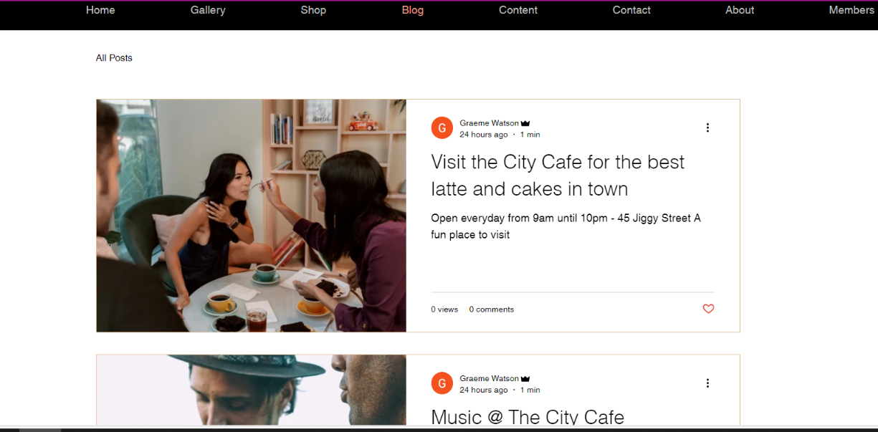

Here you can see my blog page

* **Email –** As we are producing our website for educational purposes we are not purchasing a domain name and can therefore not set up email. Below you can see where you would add a mail box in the Wix Dashboard

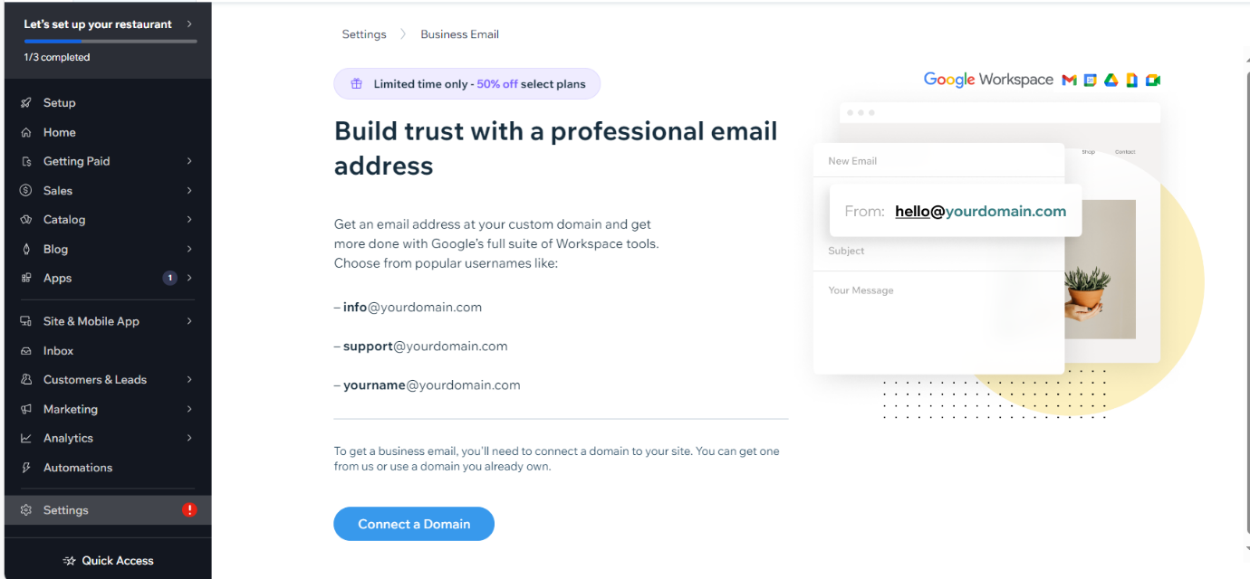

* **ecommerce** Whilst we had no requirement for ecommerce on our site it would be very easy to add. The screenshot below I have created a basic shop with some products. I have only configured the product name and photographs.

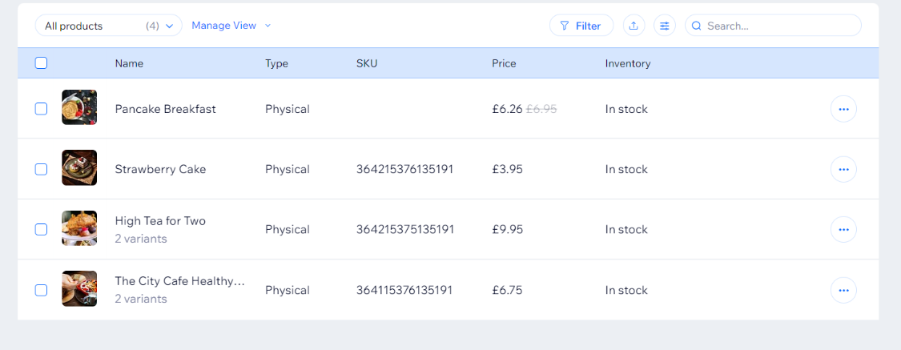

Here you can see how to manage your Shop, add products, monitor the inventory, create categories, create gift and loyalty offers and add sales channels such as Amazon or Facebook.

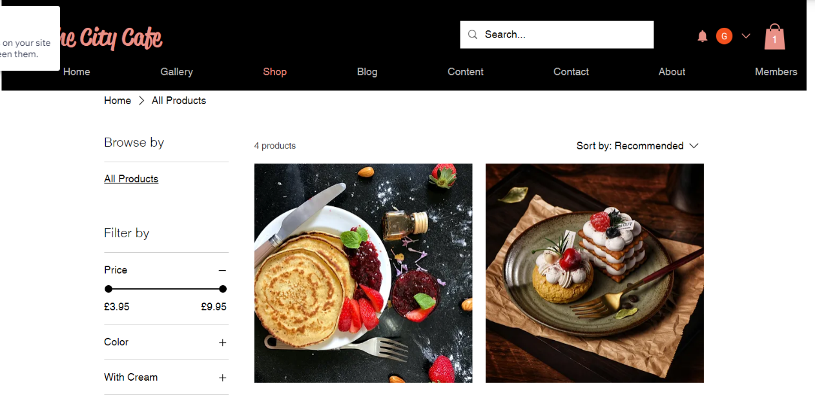

Here you can see my actual Shop page

* **Contact Form –** A contact form provides a way of letting your customers get in touch. Here you can see I have produced a contact form for my website

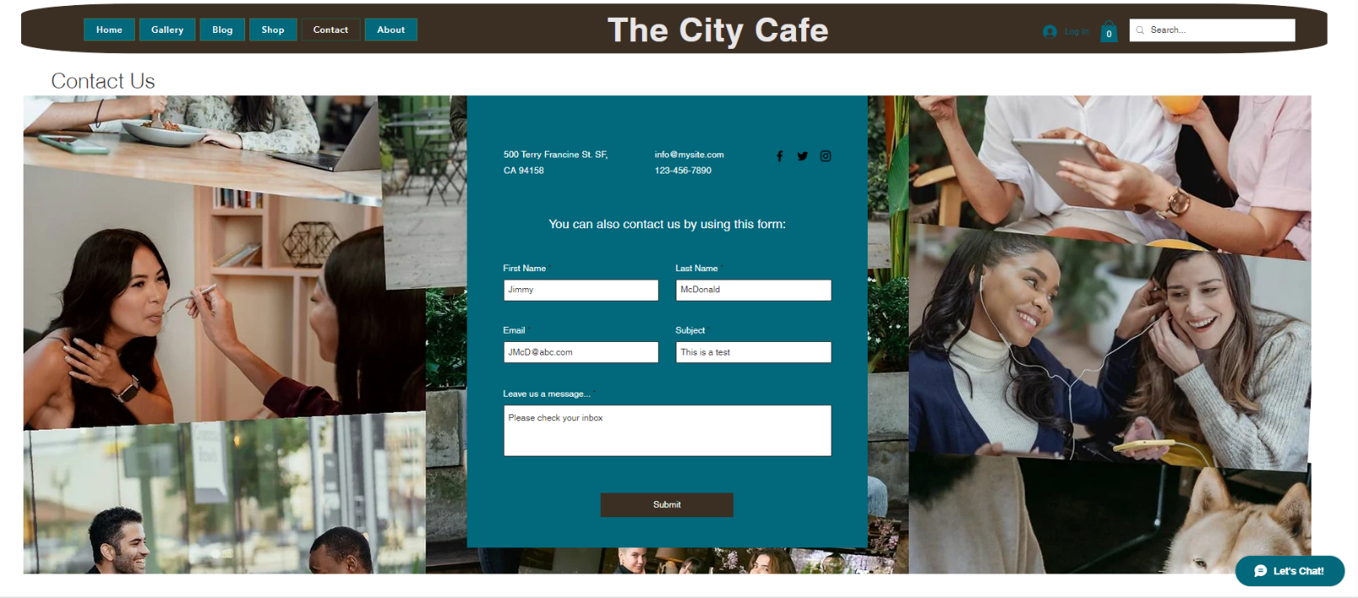

Here you can see I am testing my Contact Form

Here you can see the contact form is working

* **Database:** Every website should have an underlying database where all of the business data can be secured and accessed in one place. This improves security and reduces issues with redundancy of data.

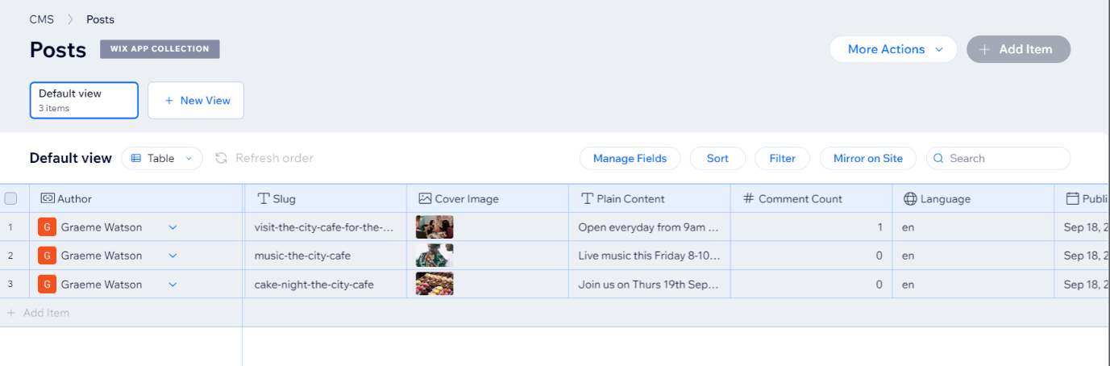

Here you can see the Database table which contains all of my posts

* **Security:** One example of website security is membership permissions. This screenshot shows where we can limit or allow different permissions and roles for different users

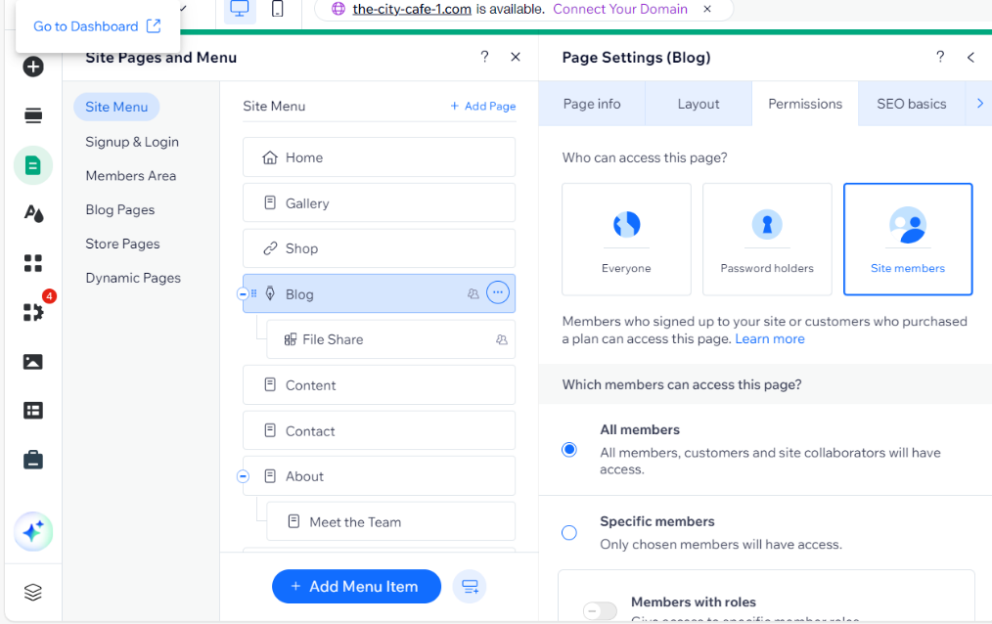

**(25 Minutes)**

**Other components**

* **Domain name: register website name** Most website hosting companies such as Wix, GoDaddy or Ionos will provide facilities to search for register and buy a domain name for your website. Below is a screenshot of how to get a domain name for your Wix site.

In Wix you would purchase your Domain Name via the set up options – as above

* **Hosting: buy a space for website** Website hosting companies offer a variety of plans for hosting your website depending on the size, features and add-ons you would like. These plans are very customizable but can quickly become expensive. You can often also purchase additional services such as design or security. Below is a screenshot of Wix plan choices.

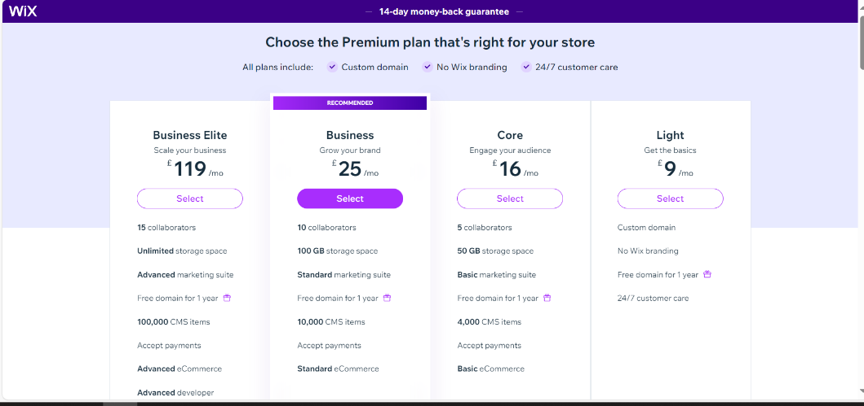

**(10 minutes to complete )**